The Impact of the Maize Value Chain on farmer’s income in Davanagere District in Karnataka
LIKHITHA S ¹, MANISH K L² AND CHANNAVIRAGOUDA
- III PhD Scholar (Agricultural Economics), Department of Agricultural Economics, UAS, GKVK, Bengaluru - 560 065
- III PhD Scholar (ABM), Institute of Agri-Business Management, UAS, GKVK, Bengaluru - 560 065
- III PhD Scholar (Agricultural Economics), Department of Agricultural Economics, UAS, GKVK, Bengaluru - 560 065

Abstract
This study evaluates the impact of the maize value chain on farmers’ income in Davanagere district, Karnataka, and identifies constraints faced by stakeholders. Karnataka contributes 14.88 per cent of India’s maize area and 14.80 per cent of its production, with Davanagere emerging as a hub for maize processing and marketing. Data was collected through interviews with 120 farmers and 15 market functionaries, using snowball sampling. Farmers utilizing FPO-led market channels earned ₹6,307.8/ha more than those using traditional channels, as revealed by regression adjustment models. Factors such as FPO distance, institutional credit access, and FPO marketing activity significantly influenced participation in FPO-led channels, as determined by a binary logit regression model. Key constraints included limited credit access, logistical challenges, and inadequate FPO outreach. Strengthening FPO networks, improving credit facilities, and addressing logistical inefficiencies could enhance farmer incomes and the efficiency of the maize value chain. The study underscores the transformative role of FPOs in agricultural value chains.
Keywords: Maize, Value Chain, FPO, Income Generation, Regression Model
INTRODUCTION
Maize crop (Zea mays L.) has an important place in the food grain basket of our country and is the third most crucial food grain crop in India because of its contribution to food, feed, specialty corn, starch, etc. India ranks 4th and 7th in global maize acreage and production, contributing to 4.6 per cent and 2.4 per cent, respectively. Maize is sometimes referred to as the miracle crop or the ‘Queen of Cereals’ because of its high yield potential. It directly contributes almost 10 percent to the Indian food basket and 5 percent to the world’s dietary energy supply. After the agricultural revolution in the 1960s, dramatic changes in the production and productivity of maize have taken place. The adoption of single-cross and double-cross maize hybrids has revolutionized maize production (Kumar et, al., 2013). Some estimates indicate that India may have to produce 55 million tonnes of maize to meet its requirement for human consumption, poultry, piggery, pharma industry, and fodder by 2030 (Chaudhary et al., 2012).
A value chain is a series of interconnected economic operations (functions), starting with the provision of specified inputs for a given product and continuing through primary manufacturing, transformation, and marketing to the consumer. (GTZ Value Links, 2008). The production-distribution or activity-marketing channels found in the pre-intervention value chain and the FPC (Farmer Producer Company) intervention found in the post-intervention value chain make up the maize value chain (Department of Agriculture and Marketing Cooperatives & Ministry, 2019). By expanding the backward and forward linkages in agriculture, value chains serve as a crucial stimulant for increasing farmers' income. In order to organise farmers and facilitate access to markets, funding, inputs, and technologies, a number of governmental interventions are being made. Indian case studies demonstrate that farmers that participate in value chains pay less in transaction costs, experience less market risks, and make more money. However, addressing many of the value chains' weak links is necessary to increase their effectiveness and inclusiveness (Chengappa, 2018). There are three major categories of maize usage in India: feed, food, and industrial. In India, 60 percent of the maize consumed goes toward animal feed. Farmers, aggregators/traders, processors (Feed industry/Starch industry), and consumers (Poultry industry/Food or feed industry) are the key players in the maize value chain in India (Parveen et al., 2021).

The Government of India launched a pilot programme called Farmer Producer Organizations (henceforth, FPOs) through the Small Farmers' Agribusiness Consortium in 2011–12 to integrate small farmers with the agricultural market for more lucrative prices with low transaction costs and encourage them to sell their surplus production (SFAC). The goal of the establishment of FPOs is to organise farmers, particularly small producers, at various levels across a number of states in order to promote technology adoption, boost productivity, enable better access to inputs and services, and raise farmer incomes, strengthening their reliance on sustainable agriculture for a living (Government of India, 2013). More than half of the farmers who have been mobilised come from four states: Karnataka, Madhya Pradesh, Tamil Nadu, and West Bengal. Karnataka has the highest concentration of promoting institutions (85), making up around 8.9 per cent of all promoting agencies operating in the nation (Manaswi et.al., 2018). FPOs' main goal is to improve small farmers' forward and backward connections by giving them access to technology, inputs, and the market. Farmers are organised through farmer informal groups (FIGs), which also combine input demand and produce, lower transaction costs, and promote economies of scale (Singh et. al., 2019). Karnataka is contributing 14.88 per cent and 14.80 per cent to all India area and production of maize. Many feed industries and other maize processing industries are located at Davanagere supplying maize processed products intra-state, inter-state and abroad. Based on this, the current study is under taken with the aim of understanding prospects of maize value chain by evaluate the impact of the value chain on farmer’s income.
Methodology
The present study is based on primary sources of data with objective which is assessing the impact on market chain was collected through direct interview of farmers using schedules. Data was also collected by means of telephonic interview. Karnataka state was purposively selected after reviewing the extraordinary performance of maize production and recent developments and trends on maize-based feed and fodder industry growth in the state. Karnataka stands first in area and production of maize with contribution of 14.88 per cent and 14.8 per cent respectively to total India area and production. Davanagere district is also purposively selected as it is the major contributor of maize in Karnataka. It also has emerged as the hub of feed and fodder industries in the recent decades which provides ample scope for studying market chain. In the year 2019-20 area under maize in Davanagere is 13,667 hectares which is 9.1 per cent of total maize area in Karnataka. Production of maize in Davanagere is 4.5 lakh tonnes which is 9.65 per cent of total production in Karnataka. Maize was found to be the major grown crop in all the areas of the district. The study was undertaken in Davanagere and Jagalur taluks of Davanagere district based on convenience sampling. Two villages from each taluk were undertaken for the study randomly. Hemmanbetturu and Siddanur villages were studied under Davanagere taluk and Gowdikatte and Sokke villages were studied under Jagalur taluk. Total 120 farmers were selected for the study, 30 farmers from each village were selected based on snow ball sampling. 15 market functionaries such as traders, wholesalers, dealers were surveyed based on snowball sampling. FPO were functioning well in the area. The FPOs near to the sample villages were surveyed.

Fig 1: Sampling frame work of the study area
Analytical tools
To study the impact of value chain on farmers income, Regression adjustment model for treated variables was used. Marketing maize through FPO was selected as treated channel assigned 1 and marketing through village traders is considered as traditional channel and assigned 0 against which impact was assessed. Stata software was used for performing analysis. The software runs on the logic that two regressions are carried out separately for treated and non-treated. The difference between them is considered as impact.
For Farmer’s adopting the market channel (with treatment)

$$Yi= ∝ + βjXij+Ui$$

For Farmer’s not adopting the market channel (without treatment)

$$Yo= ϑ+ τjXij+ei$$
Where Yi – Farmer income who adopted market channel through FPO
Yo – Farmer income who did not adopt market channel through FPO
Xij – All the variables other than study variable which affect Farmer’s income like age, farm size, education level, gender, area under maize, area under other crops Irrigated/rainfed land, seed material, tractor possession are considered. Average treatment effect on the treated was used to assess the effect of FPO channel marketing on farmers income.
Binary logit regression model
To explore the effect of explanatory variables on the dependent variable which is farmers opting marketing through FPO, binary logit regression model was used. The resultant variables take 0 and 1that is binary outcomes and hence logit model was used.
According to the model used, producer takes the marketing of produce through FPO that takes value 1 and if the producers do not take up marketing through FPO then it is takes the value 0. The probability of observing 1 is given by
$Pt(yt=\frac{1}{xtβt}$) = F(-x_{t}β_{t})
The probability of observing 0 is given by
$Pt(yt-\frac{0}{xtβt}$) = 1- F(-x_{t}β_{t})
With this specification. Maximum likelihood estimation is done to estimate parameters of the model. The equation is given by
$yt-βtxt+ui$
Where ui is the random disturbance term.
The binary logit model guarentees that estimated probabilities lie in between 0-1 and is non-linearly related to explanatory variables.
Logit model for the present study is specified as
$$Li=\ln\left(\frac{Pi}{1-Pi}\right)$$
$= β0+β1 Edu, β2 landhol,β3 dist,β4 crdtsrce, β5cntrct, β6mem,β7act$)
Education is years of education possessed by participant, landhol is the actual landholding of participant, dist is distance of FPO that is marketing maize measured in km, crdtsrce is whether that participant gets institutional or non-institutional credit, cntrct is dummy variable of partcipant’s contract with wholesaler, mem is dummy variable of membership of participant in FPO, act is whether the nearest FPO is undertaking marketing of maize or not which is dummy variable.
Map of sample area:
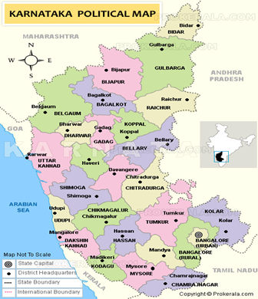

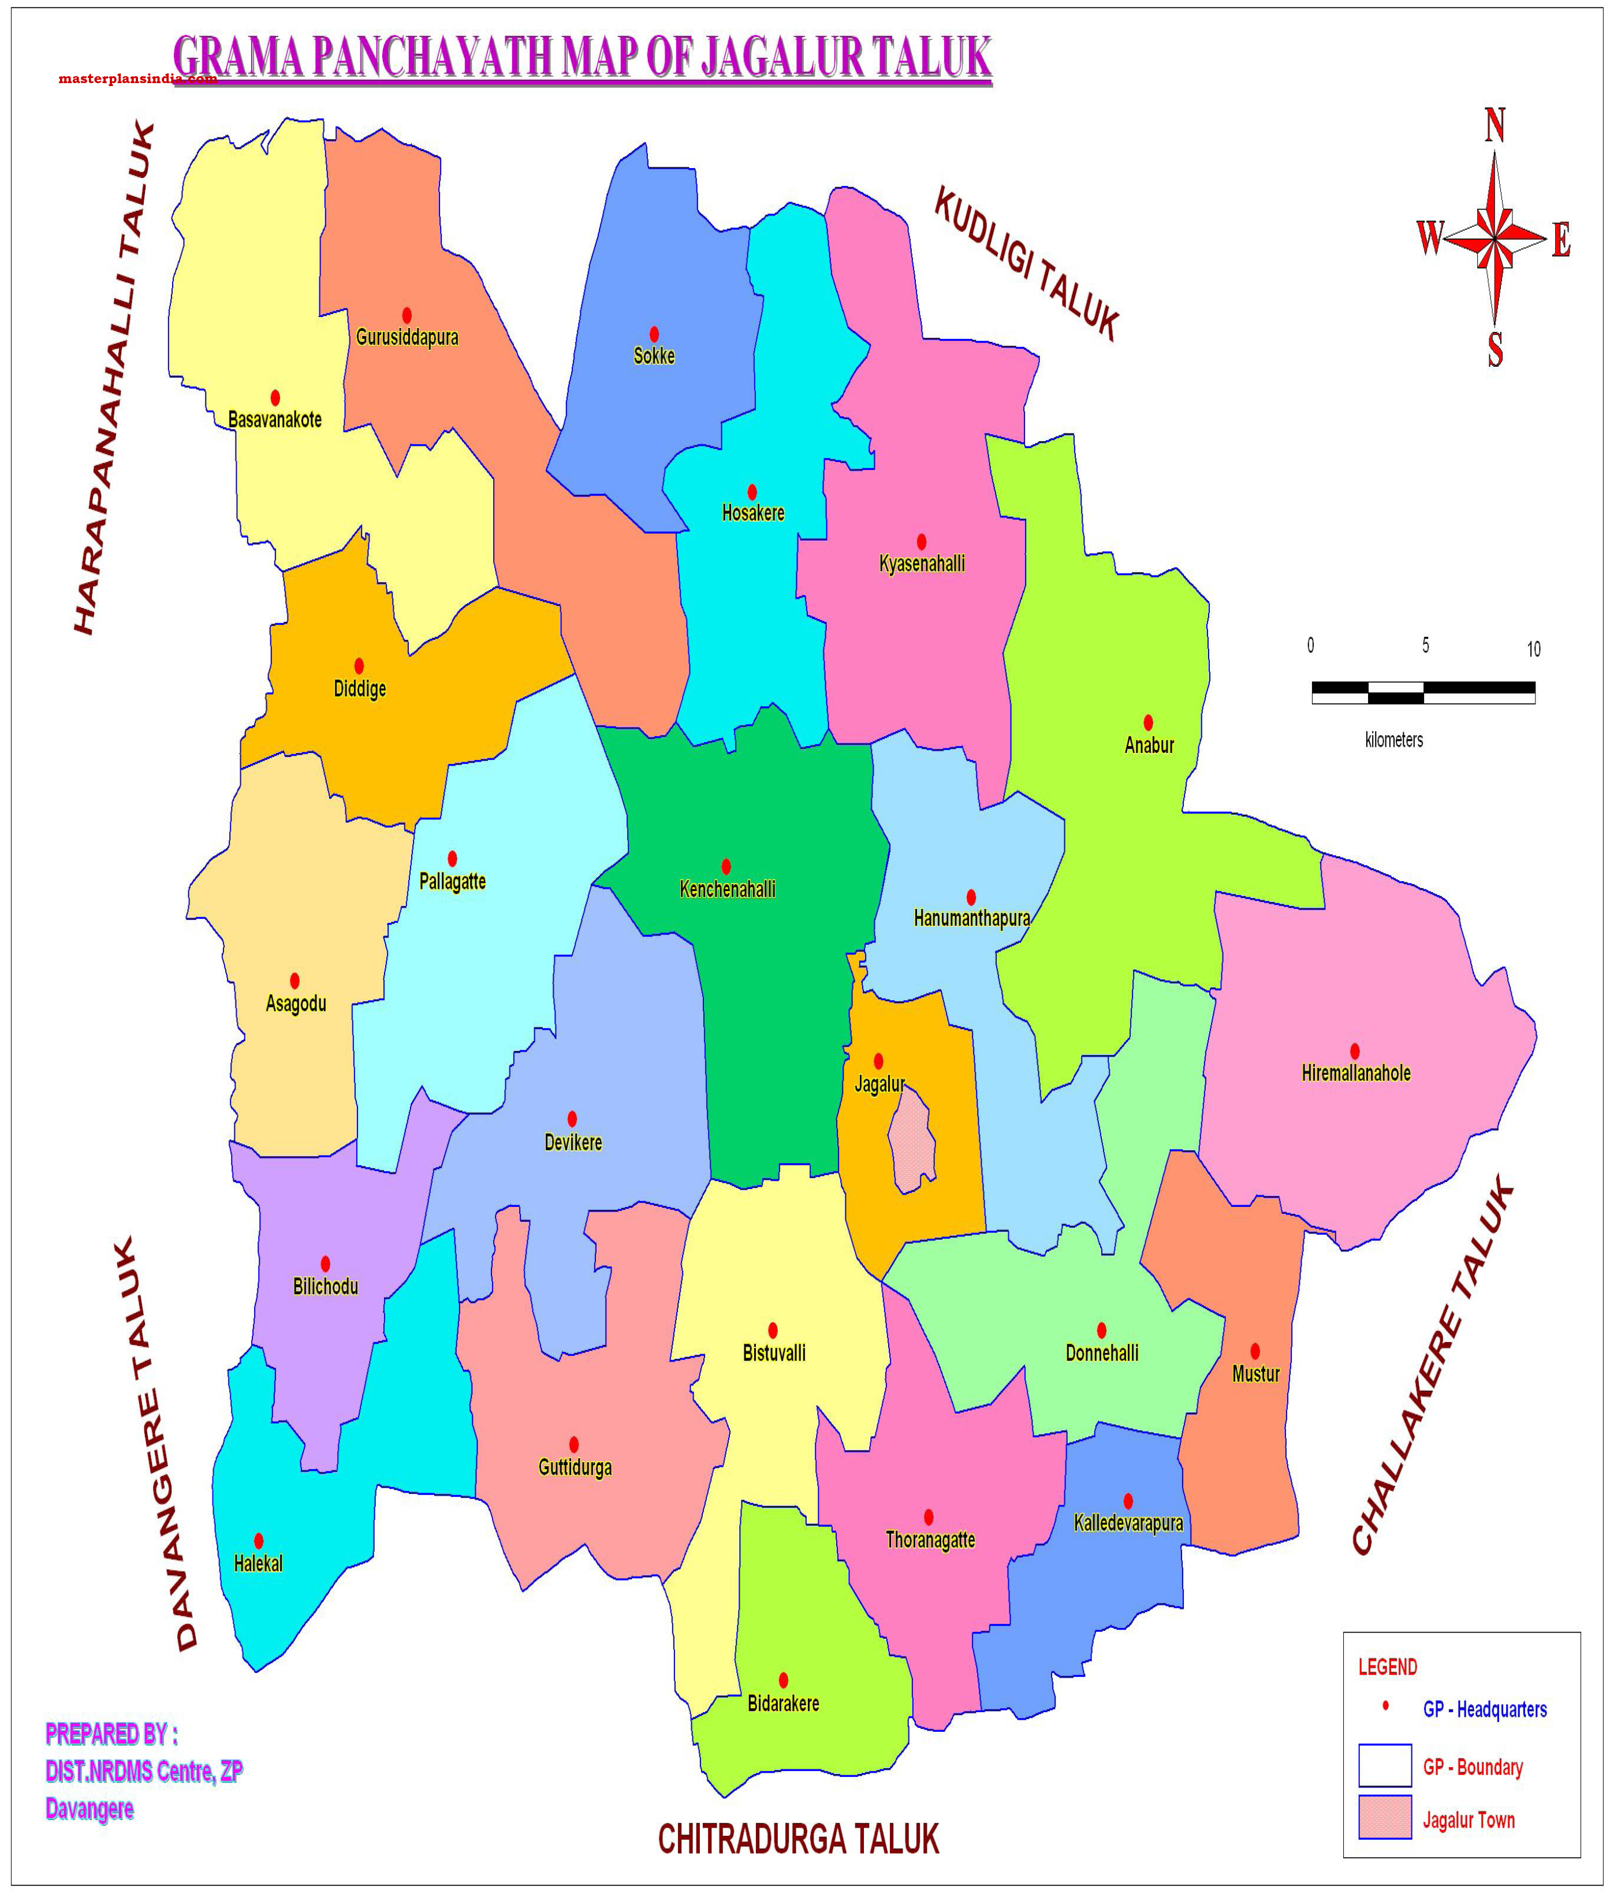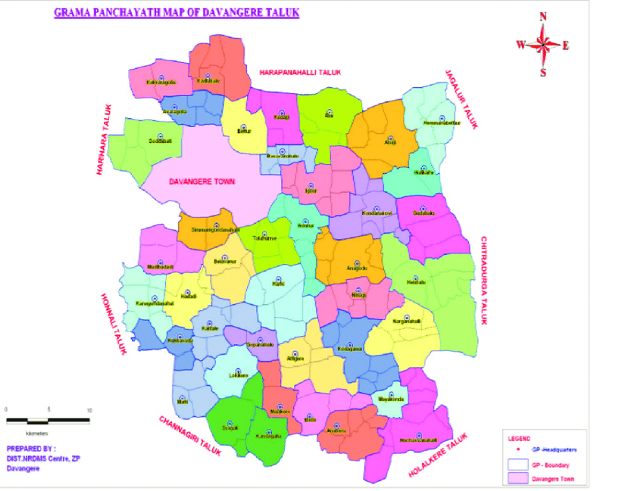

RESULTS AND DISCUSSION
Table 1: FPO for marketing maize in Davanagere district
Sl. No. | FPO | Villages taking part | Distance (km) | FPO age(years)
1 | FPO-I (Devarahalli) | Chikkaganjur | 8 | 7
1 | FPO-I (Devarahalli) | Santhebennur | 7.5 | 7
1 | FPO-I (Devarahalli) | Manjenahalli | 8 | 7
2. | FPO-II (Pallagatte) | Basavapura | 10 | 4
2. | FPO-II (Pallagatte) | Hemmanbetturu | 15 | 4
2. | FPO-II (Pallagatte) | Melamachikere | 9.5 | 4
3. | FPO-III (Harihara) | Belludi | 8.1 | 4
3. | FPO-III (Harihara) | Dheetur | 8.2 | 4
3. | FPO-III (Harihara) | Bannikodu | 9.2 | 4
3. | FPO-III (Harihara) | Karalahalli | 9.5 | 4
The table 1 provides details about Farmer Producer Organizations (FPOs) involved in maize marketing in the Davanagere district. There are three FPOs: FPO-I (Devarahalli), FPO-II (Pallagatte), and FPO-III (Harihara). FPO-I caters to villages like Chikkaganjur, Santhebenur, and Manjenahalli, with distances ranging from 7 to 8 km, and has been operational for 7 years. FPO-II serves villages such as Basavapura, Hemmanbetturu, and Melanachikere, with distances ranging from 9.5 to 15 km, and has been functioning for 4 years. Similarly, FPO-III supports villages including Belludi, Dheetur, Bannikodu, and Karalahalli, with distances between 8.1 and 9.5 km, and has been active for 4 years. This table highlights the FPOs' reach, age, and proximity to key maize-producing villages in the district.
Socio- economic characteristics of sample farmers
In the table 2 where the characteristics of farmers who marketed produce through FPO (treated) and farmers who did not market the produce through FPO (untreated) were compared and analysed. Among treated farmers, average age of them was 37.28 years, 98 per cent of them were male, average years of formal education was 8, 85 per cent area was under irrigation, average maize area was 3.06 ha, average other crops area was 0.88 ha, 90 per cent of them used hybrids, 27.5 per cent of them possessed tractors. Among untreated farmers, average age was 45.44 years, 85 per cent of them were male rest were female, Formal education possessed was 7 years, 74.12 land was under irrigation, 2.04 hectares was average maize area, other crops area was 0.92 ha, 88.3 per cent of them used hybrids, 27.05 per cent possessed tractor.
Table 2: Comparison of characteristics of treated and untreated farmers
Sl. No. | Particulars | Treated | Untreated
1 | Average age | 37.28 | 45.44
2 | Gender
2 | Male (per cent) | 98.00 | 85.89
2 | Female (per cent) | 2.00 | 14.11
3 | Education (average years) | 8 | 7
4 | Irrigation
4 | Irrigated (per cent) | 85.00 | 74.12
4 | Rainfed (per cent) | 15.00 | 25.88
5 | Average maize area (acres) | 3.06 | 2.04
6 | Other crop area (acres) | 0.88 | 0.92
7 | Farmers using
7 | local varieties | 10 % | 11.7 %
7 | Hybrids, cultivars, composites | 90 % | 88.3 %
8 | Tractor possession | 27.5 % | 27.05 %

Impact of value chain- Regression adjustment model for treatment effects
The results of regression adjustment model for treatment effects in table 3 with market channel as treatment resulted in significant results having p value less than 0.005. Potential outcome mean of market channel 0, which is traditional channel is 51,987.82 which means, if all the farmers has followed traditional market channel, they would have got 51,987.82 Rs/ha net income.
Table 3: Average treatment effects in population
Net income | Coefficient | P>|Z|
ATET Market channel (1 vs 0) | 6307.8 | 0.013
PO mean Market channel 0 | 51987.82 | 0.000

Average treatment effect on treated for market channel 1 vs 0 is 6307.80 which means, farmers following the FPO-led market channel gets 6307.80 rupees/ha more net income than farmers not following the channel. Based on this we can say that the farmers under taking FPO-led market channel are having absolute advantage than farmers who are not.
Factors influencing joining FPO-binary logit regression model for
Though the farmers have absolute advantage in following FPO-led marketing some of the other factors have influence in decision making of the farmers. Binary logit regression on various factors and farmers taking up FPO-led marketing showed that among the factors such as education, farmer category, distance of FPO marketing maize, source of credit, contract with merchants, membership of farmer in FPO, whether nearby FPO is involved in marketing of maize or not are considered. Summary statistics of the model is presented in the table 4.
Table 4: Summary statistics of variables
Variable | Mean | Standard Deviation | Minimum value | Maximum value
Education | 7.46 | 3.55 | 0 | 14
Farmer category | 1.71 | 0.46 | 1 | 2
Distance of FPO marketing maize | 13.07 | 4.87 | 2 | 22
Source of credit | 1.34 | 0.47 | 1 | 2
Contract with merchant middle men | 0.13 | 0.34 | 0 | 1
Whether nearby FPO is marketing maize | 0.32 | 0.47 | 0 | 1
Mean, standard deviation, minimum and maximum value is presented. Standard deviation is more for variable distance of FPO marketing maize and education. The results of binary logit regression model are presented in the table 5. Distance of FPO that is marketing maize, source of credit whether it is institutional or non-institutional credit and whether the nearest FPO is marketing maize are significant in the model. The interpretation of results revealed that distance and decision of farmer are positively related. As the distance of FPO that is marketing maize increases by one unit farmers decision to undertake FPO-led marketing decreases by 0.89 units. The dummy variables source of credit and whether nearest FPO marketing maize showed positive and significant relationship with farmers undertaking model. Farmers undertaking FPO-led marketing channel increases as the institutional credit increases. Farmers undertaking FPO-led marketing channel increases as the nearest FPO to farmer increases marketing of maize.
Table 5: Summary statistics of variables
Market channel | Coefficient | P>|z|
Education | 0.06 | 0.792
Farmer category | 1.84 | 0.202
Distance of FPO marketing maize | -0.89 | 0.001
Source of credit | 2.63 | 0.064
Contract with merchants | -1.48 | 0.513
Membership of farmer in FPO | -0.91 | 0.691
Whether nearby FPO is marketing maize | 4.61 | 0.044
Constant | -0.22 | 0.962

SUMMARY
This research paper explores the impact of the maize value chain on farmers' income in Davanagere district, Karnataka, while identifying constraints faced by stakeholders and suggesting measures to enhance income. Karnataka contributes 14.88 per cent of India’s maize cultivation area and 14.80 per cent of total production, positioning it as a significant player in the maize industry. Davanagere district, contributing 9.65% of Karnataka's maize production, has emerged as a major hub for maize processing and marketing due to its favourable agricultural and logistical infrastructure.
The study, based on interviews with 120 farmers and 15 market stakeholders, reveals that farmers participating in FPO-led market channels earned an additional ₹6,307.8/ha compared to those relying on traditional market channels. This was determined using regression adjustment models, which assessed the income impact of marketing channels. Furthermore, a binary logit regression model identified key factors influencing farmer participation in FPO-led channels, including proximity to FPOs, access to institutional credit, and active FPO marketing in the region.
Despite these advantages, several constraints limit the value chain's efficiency, such as restricted access to credit, logistical challenges in transporting produce, and limited outreach of FPOs in remote areas. Garrett ranking further identified farmers’ concerns about FPO membership benefits, market access, and transaction costs. Addressing these issues requires strengthening FPO infrastructure, improving access to credit, expanding transportation facilities, and enhancing capacity-building efforts for stakeholders. This study underscores the transformative role of value chains in improving agricultural income. With targeted interventions in logistics, credit access, and FPO capacity, the maize value chain has the potential to significantly uplift farmers' livelihoods, enhance market efficiency, and support sustainable agricultural growth in Karnataka.
REFERENCE:
Chaudhary, D. P., Kumar, A., Mandhania, S. S., Srivastava, P., & Kumar, R. S. 2011. Maize as fodder? An alternative approach. Directorate of Maize Research, Pusa Campus, New Delhi - 110 012, Technical Bulletin 2012/04 pp. 32.
Chengappa, P. G. (2018). Development of agriculture value chains as a strategy for enhancing farmers’ income. Agricultural Economics Research Review, 31(347-2018-3185), 1-12.
Government of India (2013), Policy and Process Guidelines for Farmer Producer Organisations, Dept. of Agriculture and Cooperation, Ministry of Agriculture, New Delhi.
Kumar, R., Srinivas, K., & Sivaramane, N. (2013). Assessment of the maize situation, outlook and investment opportunities in India. Country Report–Regional Assessment Asia (MAIZE-CRP), National Academy of Agricultural Research Management, Hyderabad, India, 133.
Manaswi, B. H., Kumar, P., Prakash, P., Anbukkani, P., Kar, A., Jha, G. K., & Rao, D. U. M. (2018). Progress and performance of states in promotion of farmer producer organisations in India. Indian Journal of Extension Education, 54(2), 108-113.
Parveen, S. N., Rao, I. S., Vidyasagar, G., Kumari, R. V., & Chary, D. S. 2021. Inventory Management of Maize value chain partners in Telangana State of Inventory management of maize value chain partners in Telangana state of India. January 2022.
Singh, G., & Vatta, K. (2019). Assessing the economic impacts of farmer producer organizations: a case study in Gujarat, India. Agricultural Economics Research Review, 32(347-2020-1020).
ValueLinks, G. T. Z. (2008). ValueLinks Manual—The Methodology of Value Chain Promotion, Germany.
Yadav, V. K., Supriya, P., Kumar, S., & Manikanhaiya, C. Y. (2016). Issues related to low productivity of maize in Haryana. Indian Research Journal of Extension Education, 11(3), 14-18.

